Dimensionality Reduction
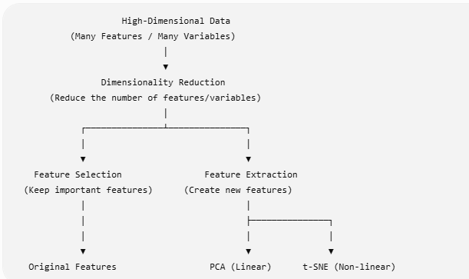

Introduction to Dimensionality Reduction
Dimensionality reduction is a technique used to reduce the number of features in a dataset while preserving important information. It transforms high-dimensional data into a lower-dimensional space for simpler representation.
- Reduces computation time by lowering the number of features
- Helps prevent overfitting by removing irrelevant data
- Improves data visualization and understanding
For example, when you are building a model to predict house prices with features like bedrooms, square footage and location. If you add too many features such as room condition or flooring type, the dataset becomes large and complex.

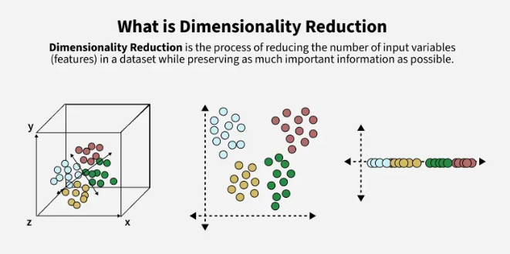

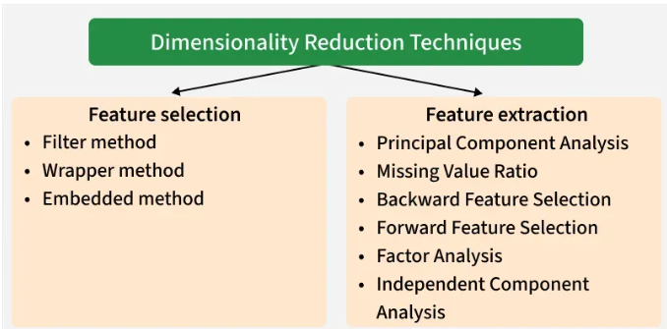
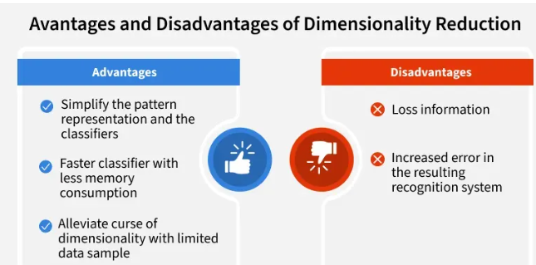

Working
Lets understand how dimensionality Reduction is used with the help of example. Imagine a dataset where each data point exists in a 3D space defined by axes X, Y and Z. If most of the data variance occurs along X and Y then the Z-dimension may contribute very little to understanding the structure of the data.

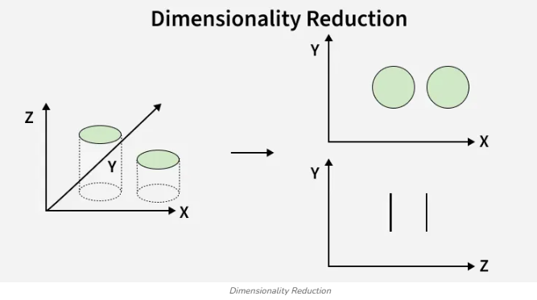
- Before Reduction we can see that data exist in 3D (X,Y,Z). It has high redundancy and Z contributes little meaningful information
- On the right after reducing the dimensionality the data is represented in lower-dimensional spaces. The top plot (X-Y) maintains the meaningful structure while the bottom plot (Z-Y) shows that the Z-dimension contributed little useful information.
This process makes data analysis more efficient hence improving computation speed and visualization while minimizing redundancy

Dimensionality Reduction Techniques
Dimensionality reduction techniques can be broadly divided into two categories:

1. Feature Selection
Feature selection chooses the most relevant features from the dataset without altering them. It helps remove redundant or irrelevant features, improving model efficiency. Some common methods are:
- Filter methods: Rank the features based on their relevance to the target variable.
- Wrapper methods: Use the model performance as the criteria for selecting features.
- Embedded methods: Combine feature selection with the model training process.
- Missing Value Ratio: Variables with missing data beyond a set threshold are removed, improving dataset reliability.
- Backward Feature Elimination: Starts with all features and removes the least significant ones in each iteration. The process continues until only the most impactful features remain, optimizing model performance.
- Forward Feature Selection: It begins with one feature, adds others incrementally and keeps those improving model performance.
- Random Forest: It uses decision trees to evaluate feature importance, automatically selecting the most relevant features without the need for manual coding, enhancing model accuracy.

2. Feature Extraction
Feature extraction involves creating new features by combining or transforming the original features. These new features retain most of the dataset’s important information in fewer dimensions. Common feature extraction methods are:
- Principal Component Analysis (PCA): Converts correlated variables into uncorrelated principal components hence reducing dimensionality while maintaining as much variance as possible enabling more efficient analysis.
- Factor Analysis: Groups variables by correlation and keeps the most relevant ones for further analysis.
- Independent Component Analysis (ICA): Identifies statistically independent components, ideal for applications like ‘blind source separation’ where traditional correlation-based methods fall short.

Principal Component Analysis (PCA)
PCA (Principal Component Analysis) is a dimensionality reduction technique and helps us to reduce the number of features in a dataset while keeping the most important information. It changes complex datasets by transforming correlated features into a smaller set of uncorrelated components.
It helps us to remove redundancy, improve computational efficiency and make data easier to visualize and analyze.
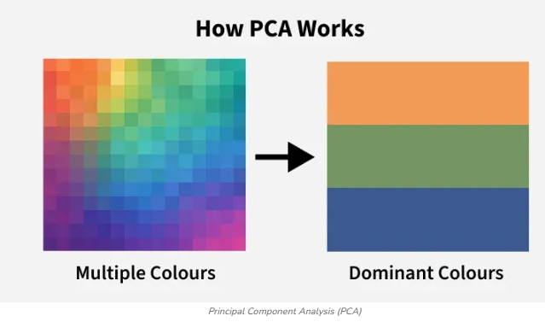

How Principal Component Analysis Works
PCA uses linear algebra to transform data into new features called principal components. It finds these by calculating eigenvectors (directions) and eigenvalues (importance) from the covariance matrix. PCA selects the top components with the highest eigenvalues and projects the data onto them simplify the dataset.

Note: It prioritizes the directions where the data varies the most because more variation = more useful information.
Imagine you’re looking at a messy cloud of data points like stars in the sky and want to simplify it. PCA helps you find the "most important angles" to view this cloud so you don’t miss the big patterns. Here’s how it works step by step:

Step 1: Standardize the Data
Different features may have different units and scales like salary vs. age. To compare them fairly PCA first standardizes the data by making each feature have:
- A mean of 0
- A standard deviation of 1

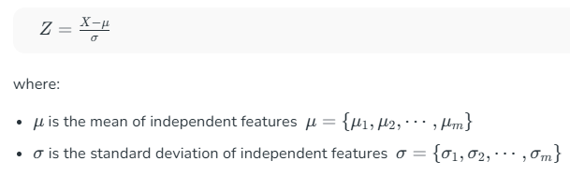

Step 2: Calculate Covariance Matrix
Next PCA calculates the covariance matrix to see how features relate to each other whether they increase or decrease together. The covariance between two features x1x1​ and x2x2​ is:
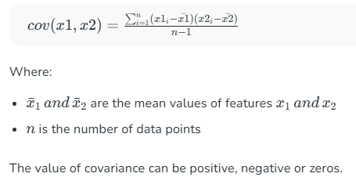

Step 3: Find the Principal Components
PCA identifies new axes where the data spreads out the most:
- 1st Principal Component (PC1): The direction of maximum variance (most spread).
- 2nd Principal Component (PC2): The next best direction, perpendicular to PC1 and so on.
These directions come from the eigenvectors of the covariance matrix and their importance is measured by eigenvalues. For a square matrix A an eigenvector X (a non-zero vector) and its corresponding eigenvalue λ satisfy:
AX=λXAX=λX
This means:
- When A acts on X it only stretches or shrinks X by the scalar λ.
- The direction of X remains unchanged hence eigenvectors define "stable directions" of A.
Eigenvalues help rank these directions by importance.

Step 4: Pick the Top Directions & Transform Data
After calculating the eigenvalues and eigenvectors PCA ranks them by the amount of information they capture. We then:
- Select the top k components that capture most of the variance like 95%.
- Transform the original dataset by projecting it onto these top components.
This means we reduce the number of features (dimensions) while keeping the important patterns in the data.

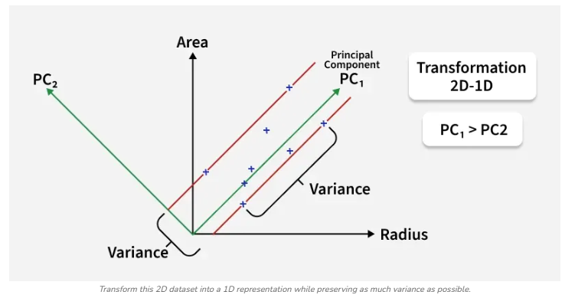
In the above image the original dataset has two features "Radius" and "Area" represented by the black axes. PCA identifies two new directions: PC₁ and PC₂ which are the principal components.
- These new axes are rotated versions of the original ones. PC₁ captures the maximum variance in the data meaning it holds the most information while PC₂ captures the remaining variance and is perpendicular to PC₁.
- The spread of data is much wider along PC₁ than along PC₂. This is why PC₁ is chosen for dimensionality reduction. By projecting the data points (blue crosses) onto PC₁ we effectively transform the 2D data into 1D and retain most of the important structure and patterns.

Implementation of Principal Component Analysis in Python
Hence PCA uses a linear transformation that is based on preserving the most variance in the data using the least number of dimensions. It involves the following steps:

Step 1: Importing Required Libraries
We import the necessary library like pandas, numpy, scikit learn, seaborn and matplotlib to visualize results.

import numpy as np
import pandas as pd
from sklearn.preprocessing import StandardScaler
from sklearn.decomposition import PCA
from sklearn.model_selection import train_test_split
from sklearn.linear_model import LogisticRegression
from sklearn.metrics import confusion_matrix
import matplotlib.pyplot as plt
import seaborn as sns

Step 2: Creating Sample Dataset
We make a small dataset with three features Height, Weight, Age and Gender.
data = {
'Height': [170, 165, 180, 175, 160, 172, 168, 177, 162, 158],
'Weight': [65, 59, 75, 68, 55, 70, 62, 74, 58, 54],
'Age': [30, 25, 35, 28, 22, 32, 27, 33, 24, 21],
'Gender': [1, 0, 1, 1, 0, 1, 0, 1, 0, 0] # 1 = Male, 0 = Female
}
df = pd.DataFrame(data)
print(df)
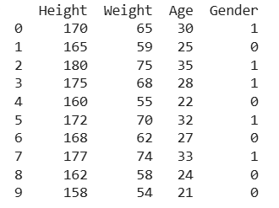

Step 3: Standardizing the Data
Since the features have different scales Height vs Age we standardize the data. This makes all features have mean = 0 and standard deviation = 1 so that no feature dominates just because of its units.
X = df.drop('Gender', axis=1)
y = df['Gender']

scaler = StandardScaler()
X_scaled = scaler.fit_transform(X)

Step 4: Applying PCA algorithm
- We reduce the data from 3 features to 2 new features called principal components. These components capture most of the original information but in fewer dimensions.
- We split the data into 70% training and 30% testing sets.
- We train a logistic regression model on the reduced training data and predict gender labels on the test set.

pca = PCA(n_components=2)
X_pca = pca.fit_transform(X_scaled)

X_train, X_test, y_train, y_test = train_test_split(X_pca, y, test_size=0.3, random_state=42)

model = LogisticRegression()
model.fit(X_train, y_train)

y_pred = model.predict(X_test)

Step 5: Evaluating with Confusion Matrix
The confusion matrix compares actual vs predicted labels. This makes it easy to see where predictions were correct or wrong.

cm = confusion_matrix(y_test, y_pred)

plt.figure(figsize=(5,4))
sns.heatmap(cm, annot=True, fmt='d', cmap='Blues', xticklabels=['Female', 'Male'], yticklabels=['Female', 'Male'])
plt.xlabel('Predicted Label')
plt.ylabel('True Label')
plt.title('Confusion Matrix')
plt.show()
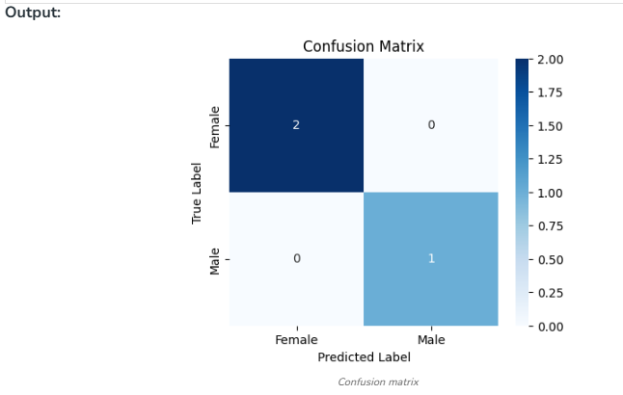

Step 6: Visualizing PCA Result

y_numeric = pd.factorize(y)[0]

plt.figure(figsize=(12, 5))

plt.subplot(1, 2, 1)
plt.scatter(X_scaled[:, 0], X_scaled[:, 1], c=y_numeric, cmap='coolwarm', edgecolor='k', s=80)
plt.xlabel('Original Feature 1')
plt.ylabel('Original Feature 2')
plt.title('Before PCA: Using First 2 Standardized Features')
plt.colorbar(label='Target classes')

plt.subplot(1, 2, 2)
plt.scatter(X_pca[:, 0], X_pca[:, 1], c=y_numeric, cmap='coolwarm', edgecolor='k', s=80)
plt.xlabel('Principal Component 1')
plt.ylabel('Principal Component 2')
plt.title('After PCA: Projected onto 2 Principal Components')
plt.colorbar(label='Target classes')

plt.tight_layout()
plt.show()

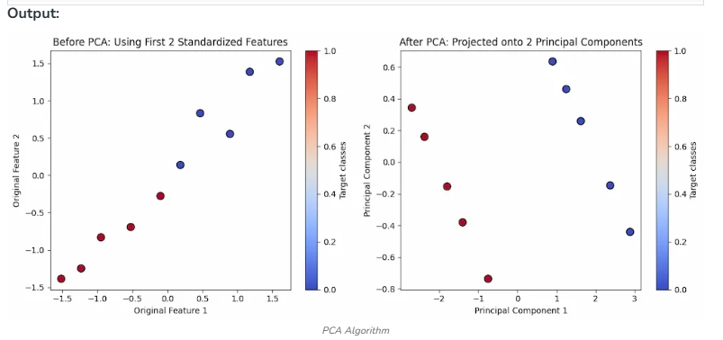
- Left Plot Before PCA: This shows the original standardized data plotted using the first two features. There is no guarantee of clear separation between classes as these are raw input dimensions.
- Right Plot After PCA: This displays the transformed data using the top 2 principal components. These new components capture the maximum variance often showing better class separation and structure making it easier to analyze or model.

Feature Subset Selection Process
Feature Selection is the most critical pre-processing activity in any machine learning process. It intends to select a subset of attributes or features that makes the most meaningful contribution to a machine learning activity. In order to understand it, let us consider a small example i.e. Predict the weight of students based on the past information about similar students, which is captured inside a 'Student Weight' data set. The data set has 04 features like Roll Number, Age, Height & Weight. Roll Number has no effect on the weight of the students, so we eliminate this feature. So now the new data set will be having only 03 features. This subset of the data set is expected to give better results than the full set.
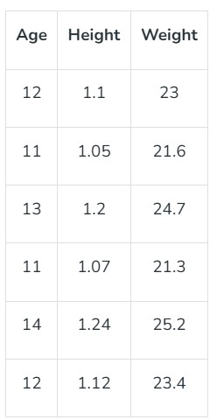
The above data set is a reduced dataset. Before proceeding further, we should look at the fact why we have reduced the dimensionality of the above dataset OR what are the issues in High Dimensional Data?
High Dimensional refers to the high number of variables or attributes or features present in certain data sets, more so in the domains like DNA analysis, geographic information system (GIS), etc. It may have sometimes hundreds or thousands of dimensions which is not good from the machine learning aspect because it may be a big challenge for any ML algorithm to handle that. On the other hand, a high quantity of computational and a high amount of time will be required. Also, a model built on an extremely high number of features may be very difficult to understand. For these reasons, it is necessary to take a subset of the features instead of the full set. So we can deduce that the objectives of feature selection are:

- Having a faster and more cost-effective (less need for computational resources) learning model
- Having a better understanding of the underlying model that generates the data.
- Improving the efficacy of the learning model.
Main Factors Affecting Feature Selection
a. Feature Relevance: In the case of supervised learning, the input data set (which is the training data set), has a class label attached. A model is inducted based on the training data set — so that the inducted model can assign class labels to new, unlabeled data. Each of the predictor variables, ie expected to contribute information to decide the value of the class label. In case of a variable is not contributing any information, it is said to be irrelevant. In case the information contribution for prediction is very little, the variable is said to be weakly relevant. The remaining variables, which make a significant contribution to the prediction task are said to be strongly relevant variables.
In the case of unsupervised learning, there is no training data set or labelled data. Grouping of similar data instances are done and the similarity of data instances are evaluated based on the value of different variables. Certain variables do not contribute any useful information for deciding the similarity of dissimilar data instances. Hence, those variable makes no significant contribution to the grouping process. These variables are marked as irrelevant variables in the context of the unsupervised machine learning task.
We can understand the concept by taking a real-world example: At the start of the article, we took a random dataset of the student. In that, Roll Number doesn't contribute any significant information in predicting what the Weight of a student would be. Similarly, if we are trying to group together students with similar academic capabilities, Roll No can really not contribute any information. So, in the context of grouping students with similar academic merit, the variable Roll No is quite irrelevant. Any feature which is irrelevant in the context of a machine learning task is a candidate for rejection when we are selecting a subset of features
b. Feature Redundancy: A feature may contribute to information that is similar to the information contributed by one or more features. For example, in the Student Data-set, both the features Age & Height contribute similar information. This is because, with an increase in age, weight is expected to increase. Similarly, with the increase in Height also weight is expected to increase. So, in context to that problem, Age and Height contribute similar information. In other words, irrespective of whether the feature Height is present or not, the learning model will give the same results. In this kind of situation where one feature is similar to another feature, the feature is said to be potentially redundant in the context of a machine learning problem.
All features having potential redundancy are candidates for rejection in the final feature subset. Only a few representative features out of a set of potentially redundant features are considered for being a part of the final feature subset. So in short, the main objective of feature selection is to remove all features which are irrelevant and take a representative subset of the features which are potentially redundant. This leads to a meaningful feature subset in the context of a specific learning task.
The measure of feature relevance and redundancy
a. Measures of Feature Relevance: In the case of supervised learning, mutual information is considered as a good measure of information contribution of a feature to decide the value of the class label. That is why it is a good indicator of the relevance of a feature with respect to the class variable. The higher the value of mutual information of a feature, the more relevant is that feature. Mutual information can be calculated as follows:
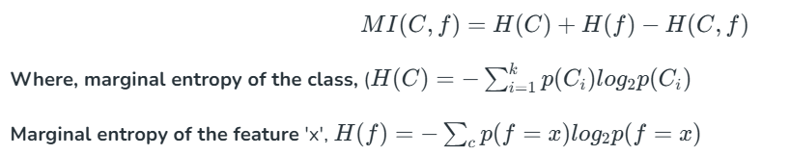
And K = number of classes, C = class variable, f = feature set that take discrete values. In the case of unsupervised learning, there is no class variable. Hence, feature-to-class mutual information cannot be used to measure the information contribution of the features. In the case of unsupervised learning, the entropy of the set of features without one feature at a time is calculated for all features. Then the features are ranked in descending order of information gain from a feature and the top ′β′ percentage (value of beta is a design parameter of the algorithm) of features are selected as relevant features. The entropy of a feature f is calculated using Shannon's formula below:
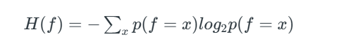
∑x​ is used only for features that take the discrete values. For continuous features, it should be replaced by discretization performed first to estimate the probabilities p(f=x).
b. Measures of Feature Redundancy: There are multiple measures of similarity of information contribution, the main ones are:
- Correlation-based Measures
- Distance-based Measures
- Other coefficient-based Measure
- 1. Correlation Based Similarity Measure
- Correlation is a measure of linear dependency between two random variables. Pearson's product correlation coefficient is one of the most popular and accepted measures correlation between two random variables. For two random feature variables F₁ and F₂ , the Pearson coefficient is defined as:
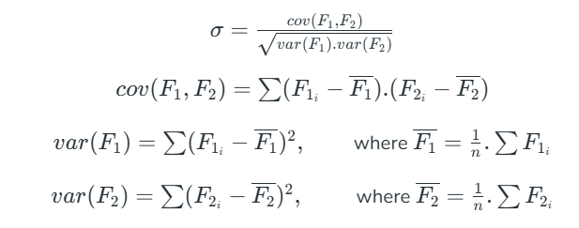
Correlation value ranges between +1 and -1. A correlation of 1 (+/-) indicates perfect correlation. In case the correlation is zero, then the features seem to have no linear relationship. Generally for all feature selection problems, a threshold value is adopted to decide whether two features have adequate similarity or not.
2. Distance-Based Similarity Measure
The most common distance measure is the Euclidean distance, which, between two features F₁ and F₂ are calculated as:
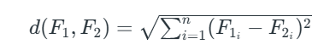
Where the features represent an n-dimensional dataset. Let us consider that the dataset has two features, Subjects (F₁) and marks (F₂) under consideration. The Euclidean distance between the two features will be calculated like this:
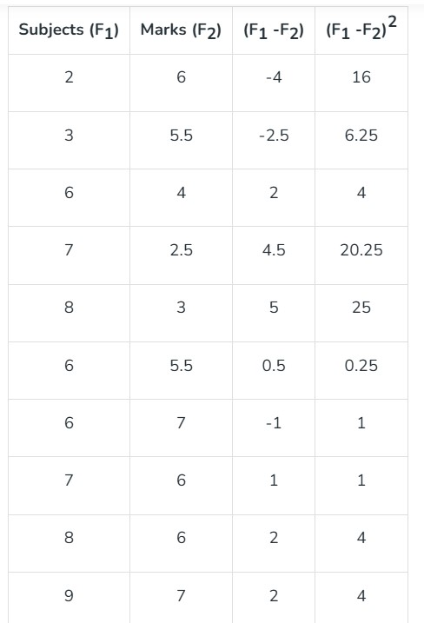
A more generalized form of the Euclidean distance is the Minkowski Distance, measured as d(F1,F2)=∑i=1n∣F1i−F2i∣rd(F1​,F2​)=∑i=1n​∣F1i​​−F2i​​∣r​
Minkowski distance takes the form of Euclidean distance (also called L₂ norm) where r = 2. At r=1, it takes the form of Manhattan distance (also called L₁ norm) : d(F1,F2)=∑i=1n∣F1i−F2i∣d(F1​,F2​)=∑i=1n​∣F1i​​−F2i​​∣
3. Other Similarity Measures
Jaccard index/coefficient is used as a measure of dissimilarity between two features is complementary of Jaccard Index.
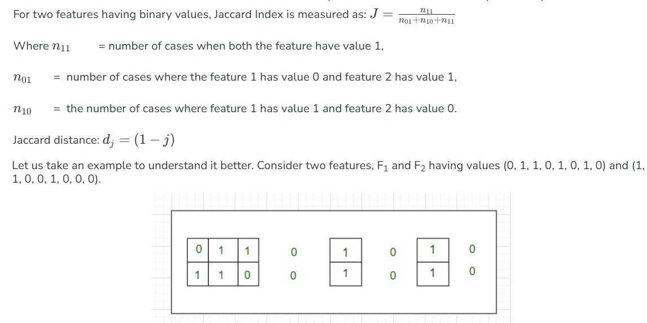
As shown in the above picture, the cases where both the values are 0 have been left out without border- as an indication of the fact that they will be excluded in the calculation of the Jaccard coefficient.
Therefore, Jaccard Distance between those two features is d_{j} = (1 - 0.4) = 0.6
Note: One more measure of similarity using similarity coefficient calculation is Cosine Similarity. For the sake of understanding, let u stake an example of the text classification problem. The text needs to be first transformed into features with a word token being a feature and the number of times the word occurs in a document comes as a value in each row. There are thousands of features in such a text dataset. However, the data set is sparse in nature as only a few words do appear in a document and hence in a row of the data set. So each row has very few non-zero values. However, the non-zero values can be anything integer value as the same word may occur any number of times. Also, considering the sparsity of the dataset, the 0-0 matches need to be ignored. Cosine similarity which is one of the most popular measures in text classification is calculated as:
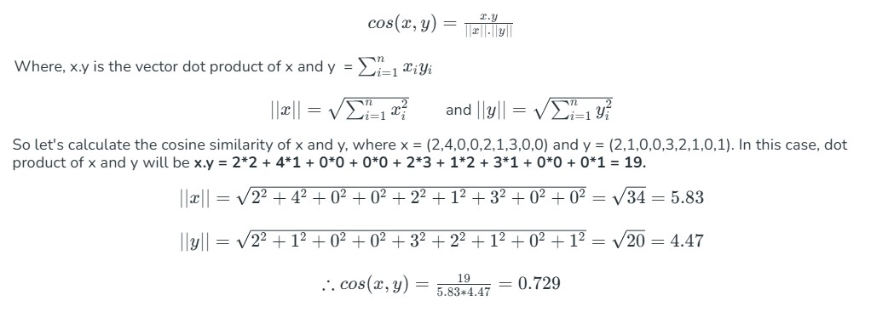
Cosine Similarity measures the angle between x and y vectors. Hence, if cosine similarity has a value of 1, the angles between x and y is 0 degrees which means x and y are the same except for the magnitude. If the cosine similarity is 0, the angle between x and y is 90⁰. Hence, they do not share any similarity. In the case of the above example, the angle comes out to be 43.2⁰.
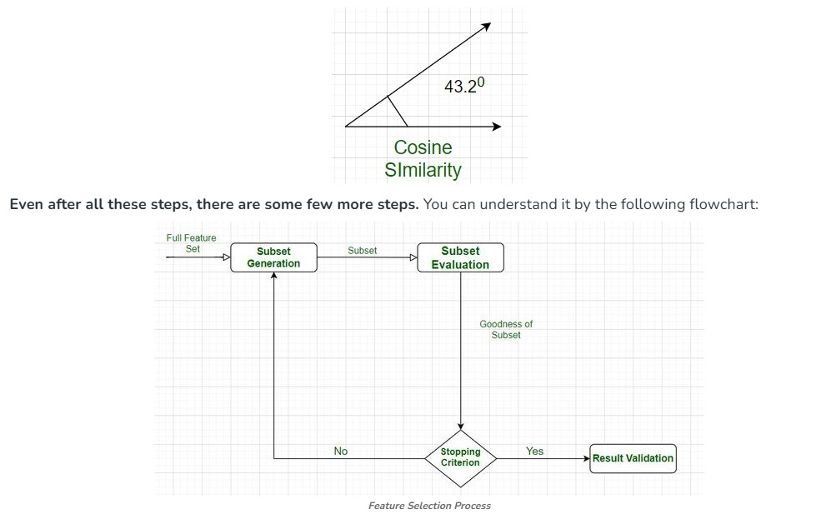
After the successful completion of this cycle, we get the desired features, and we have finally tested them also.
The feature subset selection process involves identifying and selecting a subset of relevant features from a given dataset. It aims to improve model performance, reduce overfitting, and enhance interpretability. Here is a general outline of the feature subset selection process:
Data Preparation:
Clean the data: Handle missing values, outliers, and data inconsistencies.
Encode categorical variables: Convert categorical features into numerical representations, such as one-hot encoding or label encoding.
Normalize or standardize numerical features: Scale numerical features to a common range to avoid bias.
Feature Ranking/Scoring:
Select an appropriate feature scoring or ranking method based on the nature of the data and the problem you are addressing. Common scoring methods include correlation coefficient, information gain, chi-square test, mutual information, or statistical tests like t-test or ANOVA.
Calculate the score or rank for each feature based on its relationship with the target variable.
Feature Selection Techniques:
Filter-based methods: Select features based on their individual scores or rankings. Set a threshold and select features above that threshold.
Wrapper-based methods: Use a machine learning model with different feature subsets and evaluate their performance to determine the optimal subset. Techniques like forward selection, backward elimination, or recursive feature elimination fall under this category.
Embedded methods: Incorporate feature selection as part of the model training process. Algorithms like Lasso (L1 regularization) and Ridge (L2 regularization) can automatically select relevant features during model training.
Evaluate Subset Performance:
Split the dataset into training and validation sets.
Train a machine learning model using the selected subset of features.
Evaluate the model's performance metrics (e.g., accuracy, precision, recall, F1-score, or area under the ROC curve) on the validation set.
If the performance is not satisfactory, go back to the feature selection step and try different techniques or adjust the parameters
.
Iterative Refinement:
Iterate through steps 2-4, trying different feature scoring methods, selection techniques, thresholds, or algorithms to find the optimal feature subset.
Utilize cross-validation techniques, such as k-fold cross-validation, to obtain more robust estimates of model performance and feature relevance.
Final Model Training and Testing:
Once the optimal feature subset is selected, train the final machine learning model on the entire training dataset using the selected features.
Evaluate the model's performance on an independent test dataset to assess its generalization ability.
Interpretability and Validation:
Analyze the selected features and their relationship with the target variable to gain insights into the problem domain.
Validate the selected features on new, unseen data to ensure their robustness and effectiveness.
Remember that the feature subset selection process is iterative and may require experimenting with different techniques, thresholds, and evaluation metrics to find the most suitable subset of features for your specific problem.

Feature Embedding in Machine Learning
. Introduction
Machine Learning algorithms work mainly with numerical data. However, real-world data such as words, sentences, images, audio, graphs, and categorical values are often complex and cannot be directly understood by many machine learning algorithms.
Feature Embedding is a technique used to represent data as a numerical vector in a continuous vector space.
The goal is to transform the original data into a representation that captures important features, relationships, similarities, and patterns.
For example:
"Cat" → [0.21, -0.45, 0.73, 0.12, ...]
"Dog" → [0.19, -0.42, 0.70, 0.15, ...]
"Car" → [-0.63, 0.82, -0.21, 0.55, ...]
The vectors representing cat and dog may be closer to each other than the vector representing car, because cat and dog have more similar meanings or characteristics.
Definition
Feature Embedding is the process of converting data or features into a numerical vector representation in a lower-dimensional or meaningful continuous vector space, where relationships between data points can be captured mathematically.
Why Do We Need Feature Embedding?
Traditional machine learning algorithms cannot directly understand complex data such as:
- Text
- Images
- Audio
- Graphs
- Categorical data
Feature embedding converts these data into numerical representations that machine learning models can process.
Example
Consider the categorical feature:
Color = {Red, Blue, Green}
A simple numerical encoding might be:
Red → 1
Blue → 2
Green → 3
But this creates an artificial ordering:
Red < Blue < Green
The model may incorrectly assume that Green is "greater than" Blue.
An embedding can instead learn a vector representation:
Red → [0.8, 0.2]
Blue → [0.1, 0.9]
Green → [0.6, 0.7]
The vector representation can capture relationships between categories.
. Basic Concepts of Feature Embedding
Vector
A vector is an ordered list of numerical values used to represent an object or data point.
Example:
Student → [0.8, 0.6, 0.9, 0.7]
Each dimension may represent some learned characteristic.
Dense Vector
A dense vector contains mostly non-zero values.
Example:
[0.25, 0.73, -0.12, 0.64, 0.91]
Dense representations are commonly used in modern machine learning and deep learning.
Embedding Space
The embedding space is the mathematical space in which data points are represented as vectors.
For example:
Dog ●
\
● Cat

● Car
Similar objects are generally positioned close together, while dissimilar objects are positioned farther apart.
The uploaded material similarly explains that embeddings represent relationships by placing similar items closer together and dissimilar items farther apart.
How Feature Embedding Works
The general process can be explained as:
Original Data
↓
Select / Learn Important Information
↓
Embedding Model
↓
Numerical Vector
↓
Embedding Space
↓
Similarity / Classification / Clustering
Step 1: Input Data
The input can be:
- Words
- Sentences
- Images
- Audio
- Graphs
- Categorical features
- Tabular data
Step 2: Embedding Model
An embedding model converts the input into a vector.
Examples:
- Word2Vec
- GloVe
- FastText
- BERT
- CNN-based models
- Autoencoders
- Node2Vec
Step 3: Vector Representation
The input is represented as a dense numerical vector.
For example:
Word: "King"

Embedding:
[0.24, -0.51, 0.72, 0.15, ...]
Step 4: Use the Embedding
The vector can then be used for:
- Similarity measurement
- Classification
- Clustering
- Recommendation
- Semantic search
- Information retrieval
Feature embedding and dimensionality reduction are related but not exactly the same.
Dimensionality Reduction
The primary goal is:
Reduce the number of dimensions while retaining important information.
Example:
100 Features
↓
Dimensionality Reduction
↓
10 Features
Feature Embedding
The primary goal is:
Convert data into a meaningful numerical vector representation that captures important relationships.
Example:
Word: "Computer"
↓
Embedding
↓
[0.25, 0.61, -0.34, 0.72, ...]
The embedding may have fewer dimensions than the original representation, but dimensionality reduction is not always its primary purpose.
Therefore:
Feature embedding can be used for dimensionality reduction, but not every embedding technique is primarily a dimensionality reduction technique.
This distinction is particularly important when teaching this topic in your Dimensionality Reduction module.

. Types of Feature Embeddings
Word Embedding
Word embedding represents individual words as numerical vectors.
Example:
King → Vector
Queen → Vector
Man → Vector
Woman → Vector
Words with related meanings tend to have similar vector representations.
Popular techniques
- Word2Vec
- GloVe
- FastText
Applications
- Sentiment analysis
- Machine translation
- Text classification
- Information retrieval
Sentence and Document Embedding
Instead of representing individual words, we can represent an entire sentence or document as a vector.
Example:
"I love machine learning"
↓
[0.23, 0.81, ...]
Applications
- Semantic search
- Document classification
- Question answering
- Text similarity
Examples include:
- BERT-based embeddings
- Sentence Transformers
- Universal Sentence Encoder
Image Embedding
Images can be converted into numerical vectors using deep learning models.
Image
↓
CNN / Vision Model
↓
Feature Vector
For example:
Cat Image → [0.12, 0.78, -0.23, ...]
Dog Image → [0.15, 0.74, -0.19, ...]
Similar images may have similar embeddings.
Applications
- Image classification
- Image search
- Face recognition
- Object recognition
- Image similarity
Audio Embedding
Audio signals can be transformed into vector representations.
Audio
↓
Audio Processing Model
↓
Audio Embedding
Applications
- Speech recognition
- Speaker identification
- Emotion detection
- Music recommendation
Graph Embedding
Graph embedding represents nodes, edges, or entire graphs as vectors.
Graph
↓
Graph Embedding Method
↓
Vector Representation
Examples:
- Node2Vec
- DeepWalk
- Graph Neural Networks
Applications
- Link prediction
- Node classification
- Community detection
- Recommendation systems
Categorical Feature Embedding
Categorical values can also be represented using learned vectors.
Example:
Category:
Apple
Samsung
OnePlus
Instead of assigning arbitrary numbers:
Apple → 1
Samsung → 2
OnePlus → 3
we can learn:
Apple → [0.2, 0.7, 0.1]
Samsung → [0.8, 0.3, 0.6]
OnePlus → [0.6, 0.4, 0.7]
This is widely used in:
- Recommendation systems
- Deep learning
- NLP
- Tabular machine learning
Word2Vec as an Example of Feature Embedding
For your class, I recommend using Word2Vec as the main example.
Suppose we have:
"The cat is sitting on the mat."
"The dog is sitting on the mat."
The words cat and dog occur in similar contexts.
The embedding model learns that:
Cat ↔ Dog
are semantically related.
The resulting vectors may look like:
Cat → [0.21, 0.45, 0.73, ...]
Dog → [0.23, 0.42, 0.71, ...]
Car → [-0.54, 0.81, -0.22, ...]
Therefore:
Distance(Cat, Dog) < Distance(Cat, Car)
This demonstrates how embeddings capture relationships between data points.
Similarity in Embedding Space
Once data is represented as vectors, we can measure similarity.
One popular method is Cosine Similarity.
The basic idea is:
If two vectors point in similar directions, they are considered more similar.
Feature embeddings are used in:
1. Natural Language Processing
- Sentiment analysis
- Machine translation
- Text classification
- Semantic search
2. Recommendation Systems
- Product recommendation
- Movie recommendation
- Music recommendation
3. Computer Vision
- Image similarity
- Object recognition
- Face recognition
4. Search Engines
- Semantic search
- Similar document retrieval
5. Generative AI and RAG
Embeddings are used to represent documents and queries as vectors so that semantically relevant information can be retrieved.
Limitations
- Quality depends on the training data.
- Embeddings can inherit bias from training data.
- High-dimensional embeddings can require significant storage.
- Interpretation of individual dimensions is often difficult.
- Different embedding models may produce different representations.
- Embeddings do not always preserve every aspect of the original data.

Feature Embedding vs PCA
This comparison is essential for your module.
Feature | PCA | Feature Embedding
Main purpose | Dimensionality reduction | Meaningful vector representation
Input | Usually numerical features | Text, images, audio, categorical data, etc.
Method | Mathematical transformation | Often learned by ML/DL models
Output | Principal components | Embedding vectors
Preserves | Maximum variance | Meaning/relationships/features
Example | 100 features → 10 PCs | Word → 300-dimensional vector

Feature Embedding
↓
Convert data into numerical vectors
↓
Represent meaningful characteristics
↓
Similar items → Similar vectors
Dissimilar items → Different vectors
↓
Used for
├── Classification
├── Clustering
├── Similarity Search
├── Recommendation
├── Semantic Search
└── Visualization
One-line definition for examination
Feature embedding is the process of transforming data into dense numerical vector representations in a continuous vector space, where important features, relationships, and similarities among data points can be captured and used by machine learning models.
Dimensionality Reduction → Introduction → Subset Selection → PCA → Feature Embedding → Factor Analysis → SVD → MDS
For Feature Embedding, teach Word2Vec as the main example, briefly introduce text, image, audio, graph, and categorical embeddings, and then explain t-SNE only as a method for visualizing high-dimensional embeddings. This will connect the topic very nicely to the rest of your Dimensionality Reduction module.

Visualization using t-SNE
t-SNE is used to visualize high dimensional word embeddings by reducing them to 2D space, helping us understand how similar words are positioned relative to each other.
Step 1: Import Libraries
- NumPy: Handles numerical data and array manipulation.
- Matplotlib: Creates plots and visualizations.
- scikit-learn: Reduces high-dimensional vectors to two dimensions for easy visualization.
- Gensim: Downloads text datasets and trains word embedding models.
import numpy as np
import matplotlib.pyplot as plt
from sklearn.manifold import TSNE
import gensim.downloader as api
from gensim.models import Word2Vec
Step 2: Load Data and Train Word2Vec Model
Loads a sample text dataset and uses it to train a Word2Vec model which creates word vectors.
corpus = api.load('text8')
model = Word2Vec(corpus)
Step 3: Select Words and Get Their Embeddings
- Chooses a list of sample words.
- Extracts their vector representations from the model as NumPy arrays.

words = ['cat', 'dog', 'elephant', 'lion', 'bird', 'rat', 'wolf', 'cow',
'goat', 'snake', 'rabbit', 'human', 'parrot', 'fox', 'peacock',
'lotus', 'roses', 'marigold', 'jasmine', 'computer', 'robot',
'software', 'vocabulary', 'machine', 'eye', 'vision',
'grammar', 'words', 'sentences', 'language', 'verbs', 'noun',
'transformer', 'embedding', 'neural', 'network', 'optimization']
words = [word for word in words if word in model.wv.key_to_index]
word_embeddings = [model.wv[word] for word in words]
embeddings = np.array(word_embeddings)
Step 4: Reduce Dimensionality with t-SNE
Uses t-SNE from scikit learn to shrink high dimensional word vectors into two dimensions for visualization.
tsne = TSNE(n_components=2, perplexity=2)
embeddings_2d = tsne.fit_transform(embeddings)
Step 5: Plot Embedding
Displays a scatter plot of the words in 2D space, labels each point with its word and displays the plot.
plt.figure(figsize=(10, 7), dpi=1000)
plt.scatter(embeddings_2d[:, 0], embeddings_2d[:, 1], marker='o')
for i, word in enumerate(words):
plt.text(embeddings_2d[i, 0], embeddings_2d[i, 1],
word, fontsize=10, ha='left', va='bottom')
plt.xlabel('t-SNE Dimension 1')
plt.ylabel('t-SNE Dimension 2')
plt.title('Word Embedding Graph (t-SNE with Word2Vec)')
plt.grid(True)
plt.savefig('embedding.png')
plt.show()
